**Exercise-8 (Dynamic Dropdown Menu)**

Develop a dynamic Dropdown Menu web application using AJAX with Servlets. Use the given sample code and modify the display content as dropdown menu instead of table and apply an event to dropdown, as it displays the selected item value in paragraph tag:

**WebApp Structure:**

**ApacheTomcat**🡪**webapps**

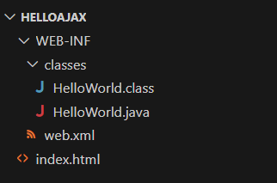

**Index.html**

<html>

<head>

<script>

function loadData() {

var xhttp = new XMLHttpRequest();

var n = document.getElementById("name").value;

    xhttp.onreadystatechange = function() {

        if (this.readyState == 4 && this.status == 200){

                var data=JSON.parse(this.responseText);

                console.log(data)

                var table=document.getElementById("menu");

                table.innerHTML="";

                var headrow=table.insertRow(0);

                var headcell=headrow.insertCell(0);

                headcell.style.backgroundColor="lightblue";

                headcell.innerHTML=data.items.name;

                var menuLen=data.items.menu;

                var i=0

                    while(i<menuLen.length){

                        row=table.insertRow(i+1);

                        cell=row.insertCell(0);

                        cell.innerHTML=menuLen[i++].name;

                      }

                    }

                };

        xhttp.open("GET","hello?name="+n,true);

        xhttp.send();

}

</script>

</head>

<body>

<h1 id="content">Iam Default Content</h1>

<input type="text" id="name">

<button onclick="loadData()">Submit</button>

<table id="menu" style="border: 2px solid black; background-color: brown;"></table>

</body>

</html>

**web.xml:**

<web-app>

<servlet>

<servlet-name>HelloWorld</servlet-name>

<servlet-class>HelloWorld</servlet-class>

</servlet>

<servlet-mapping>

<servlet-name>HelloWorld</servlet-name>

<url-pattern>/hello</url-pattern>

</servlet-mapping>

<welcome-file-list>

<welcome-file>index.html</welcome-file>

</welcome-file-list>

</web-app>

**HelloWorld.java:**

import java.io.*;

import javax.servlet.*;

import javax.servlet.http.*;

public class HelloWorld extends HttpServlet {

    public void doGet(HttpServletRequest request, HttpServletResponse response) throws IOException {

        String item1=request.getParameter("name");

       if(item1!=null){

           response.setContentType("text/json");

           PrintWriter out = response.getWriter();

           out.println(generateJSONData(item1));

       }

       }

    public String generateJSONData(String itemname){

        StringBuffer returnData=null;

        if(itemname.equals("Breakfast")){

            returnData=new StringBuffer("{\"items\":{\"name\":\"Breakfast\",\"menu\":[{\"name\":\"Dosa\"},{\"name\":\"Burger\"},{\"name\":\"Idly\"}]}}");

        }

        else if(itemname.equals("Beverages")){

            returnData=new StringBuffer("{\"items\":{\"name\":\"Beverages\",\"menu\":[{\"name\":\"Coke\"},{\"name\":\"Pepsi\"}]}}");

        }

        else{

            returnData=new StringBuffer("{\"items\":No item Found}");

        }

        return returnData.toString();

    }

}

**Output:**

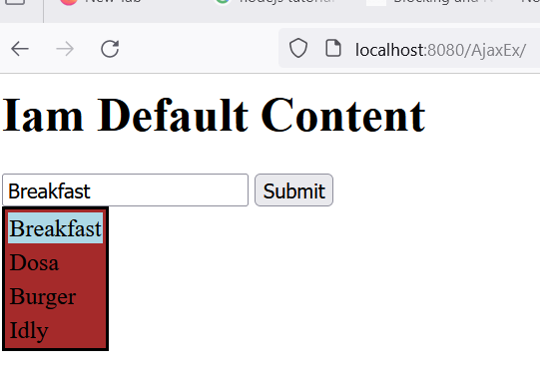

**Best Practices to be followed:**

1. Design before coding

2. Incremental coding

3. Usage of proper naming convention

4. Usage of Comments to the code

5. Indentation of code